Exercise-2

### Login-Registration-Profile

### **Login Screen :**

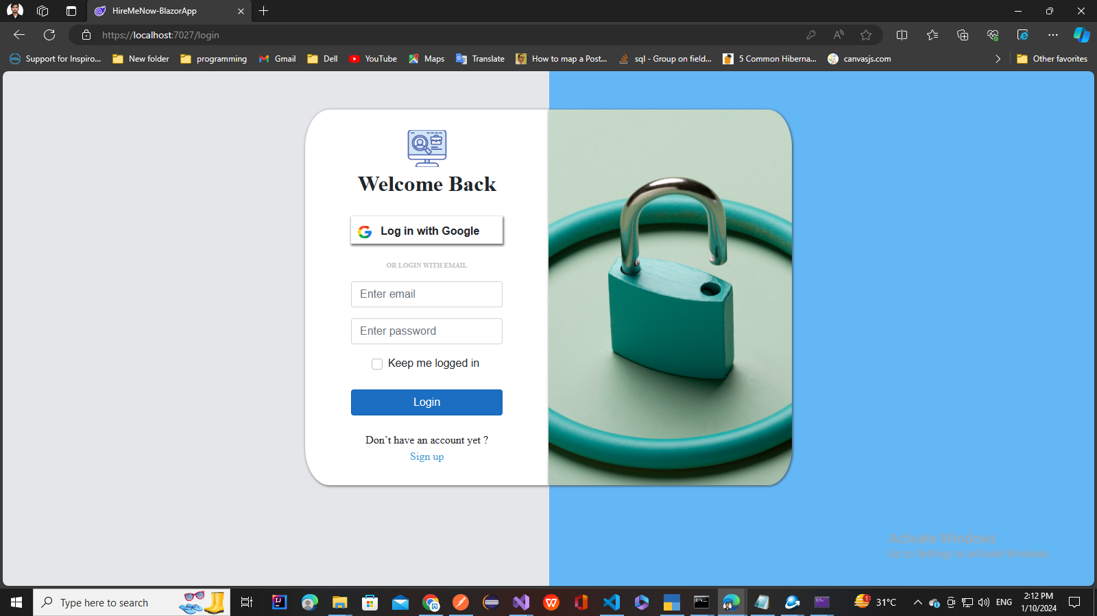

### **Registration Screen :**

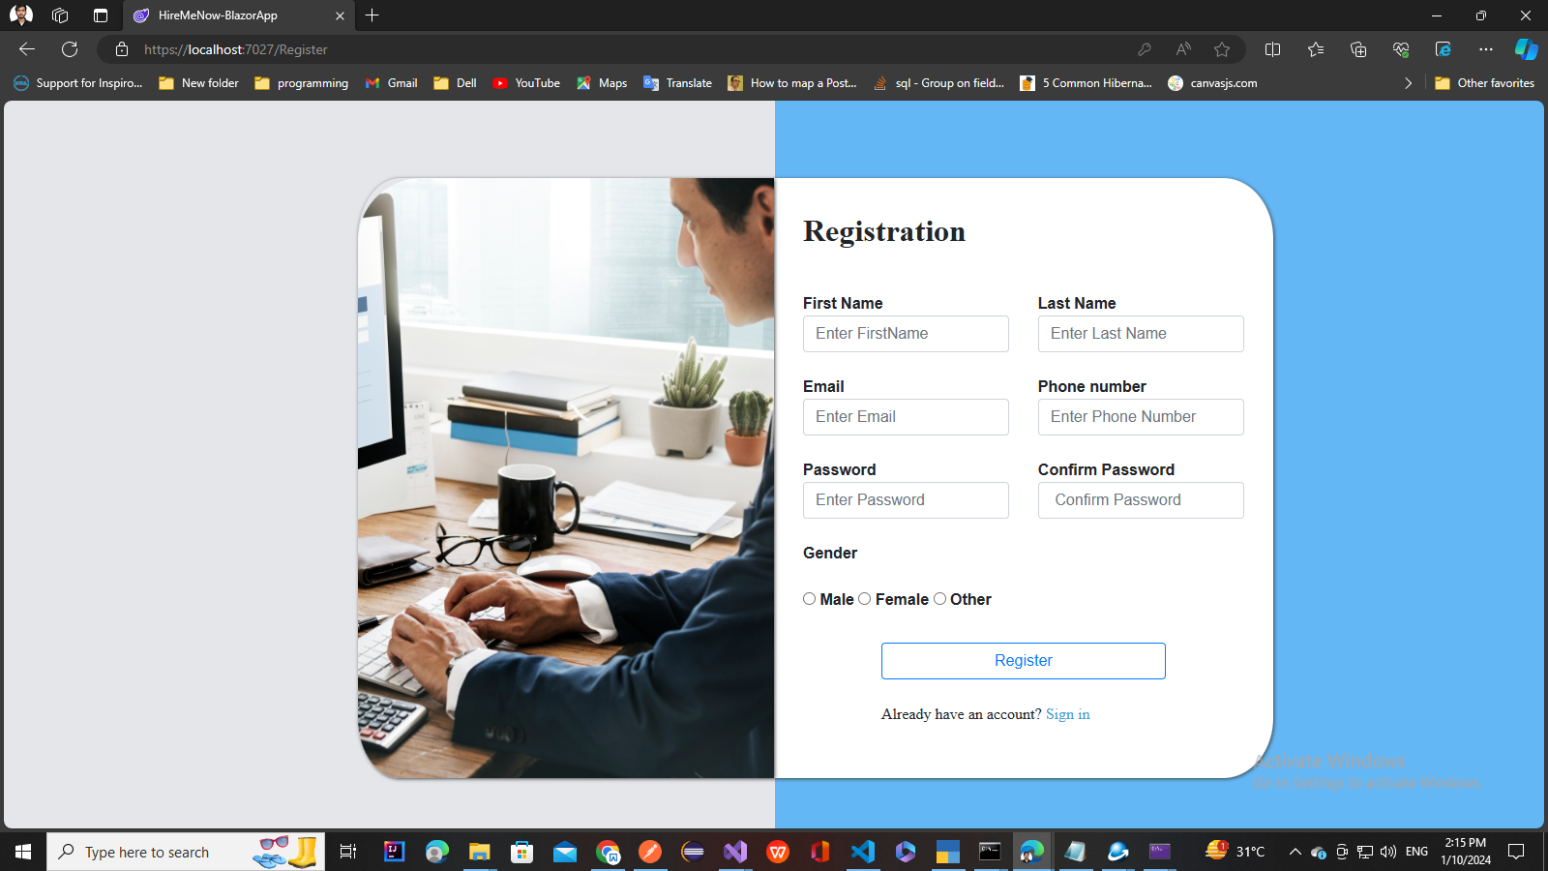

### **Job list screen**

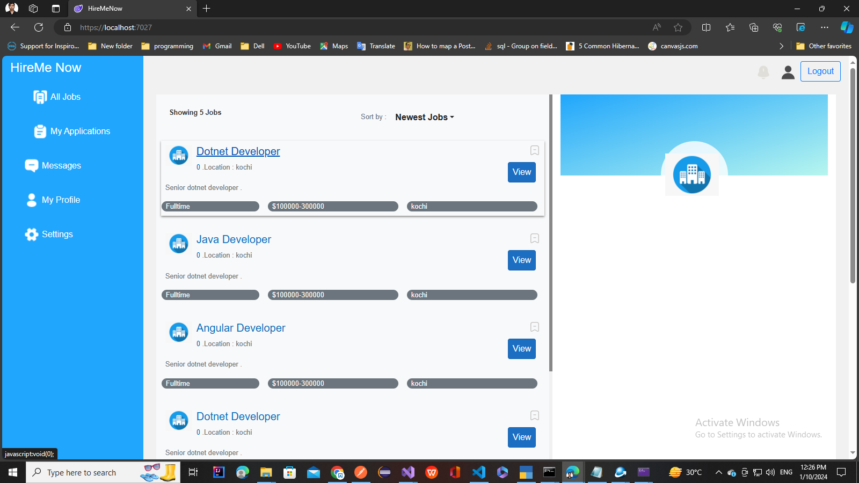

**Features to implement:**

* Design And Implement Login Screen
* Design And Implement Register Screen
* Design And Implement joblist screen